**EX. NO: 5**

**DATE: 13/10/2020**

**GOOGLE APP ENGINE**

**Screenshots:**

**Step 1:**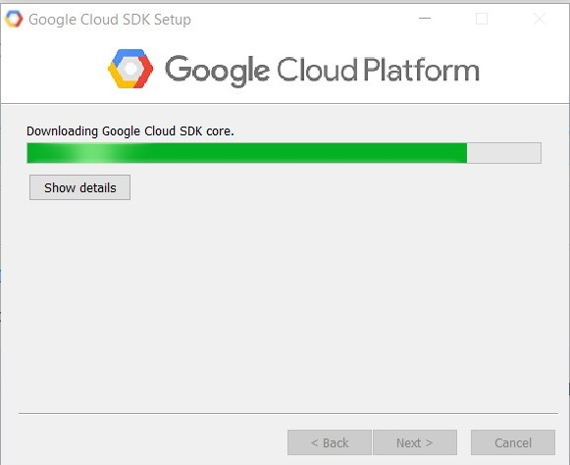

**Step 2:**

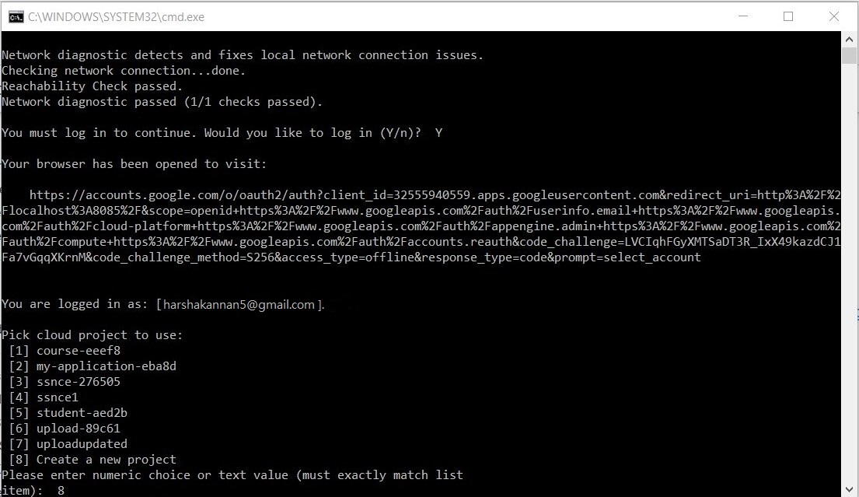

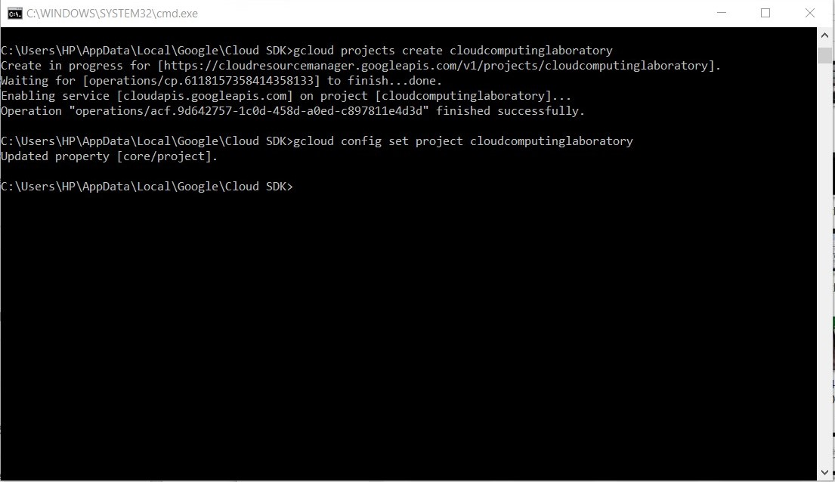**Step 3:**

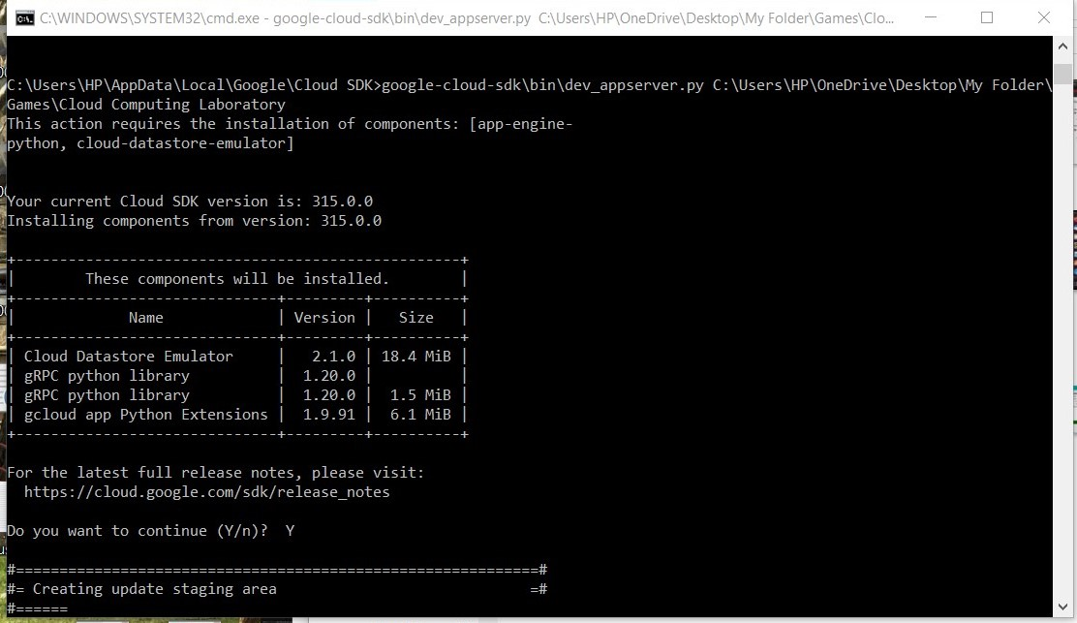**Step 4:**

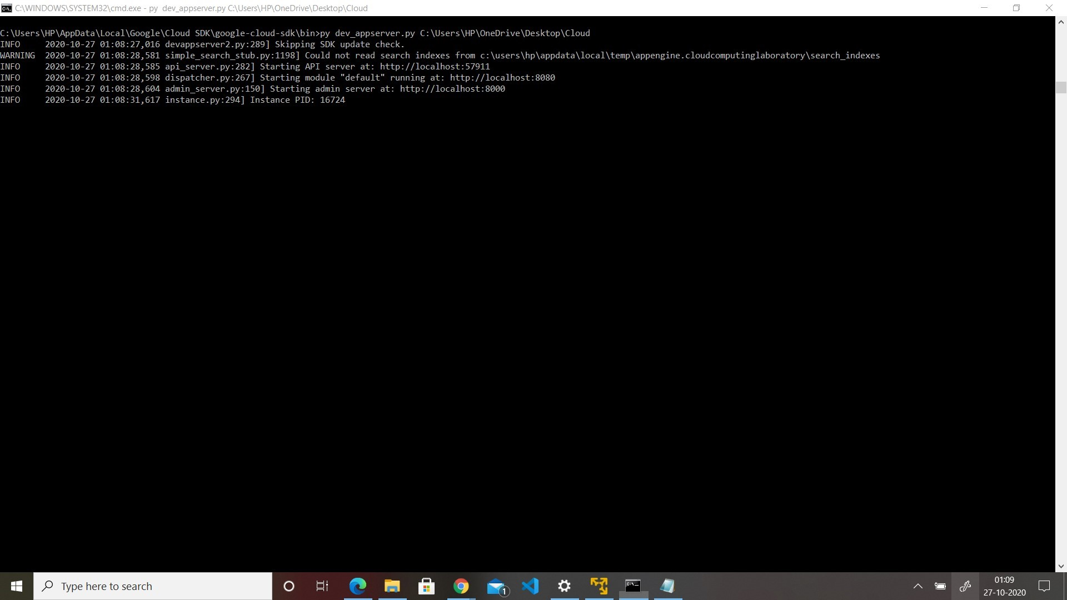**Step 5:**

**Step 6:**

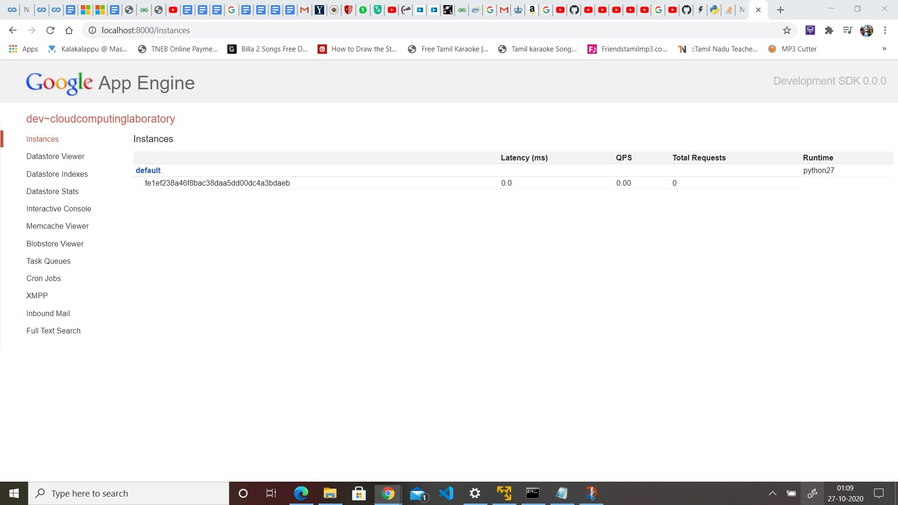

**Step 7:**

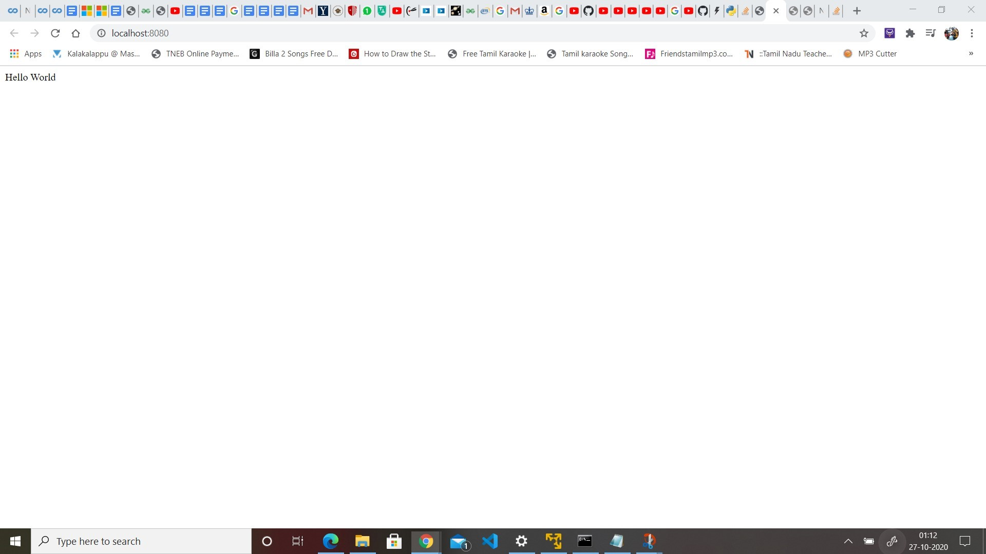**Step 8:**

**Upload Any Python FIle To The Cloud And Execute It**

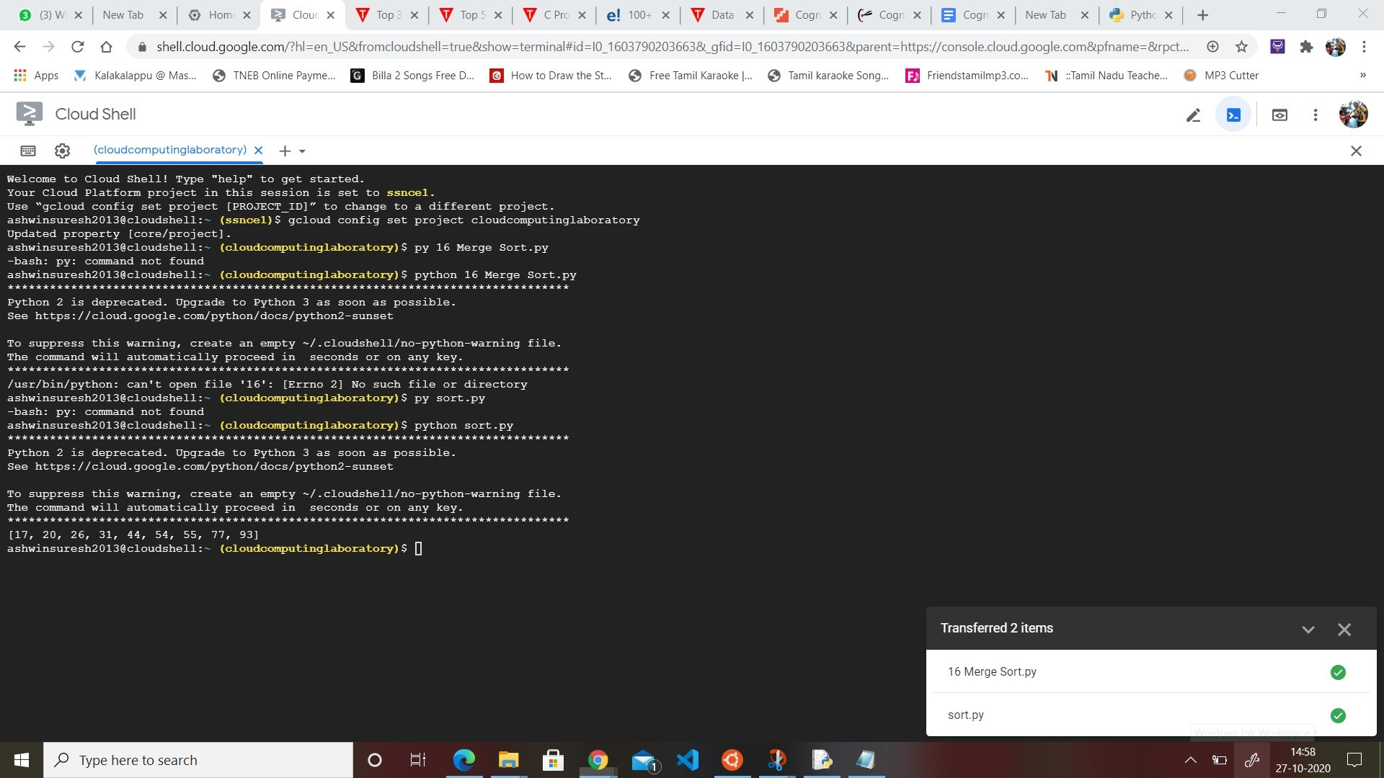

**Step 9:**

**Download The Uploaded Python File**

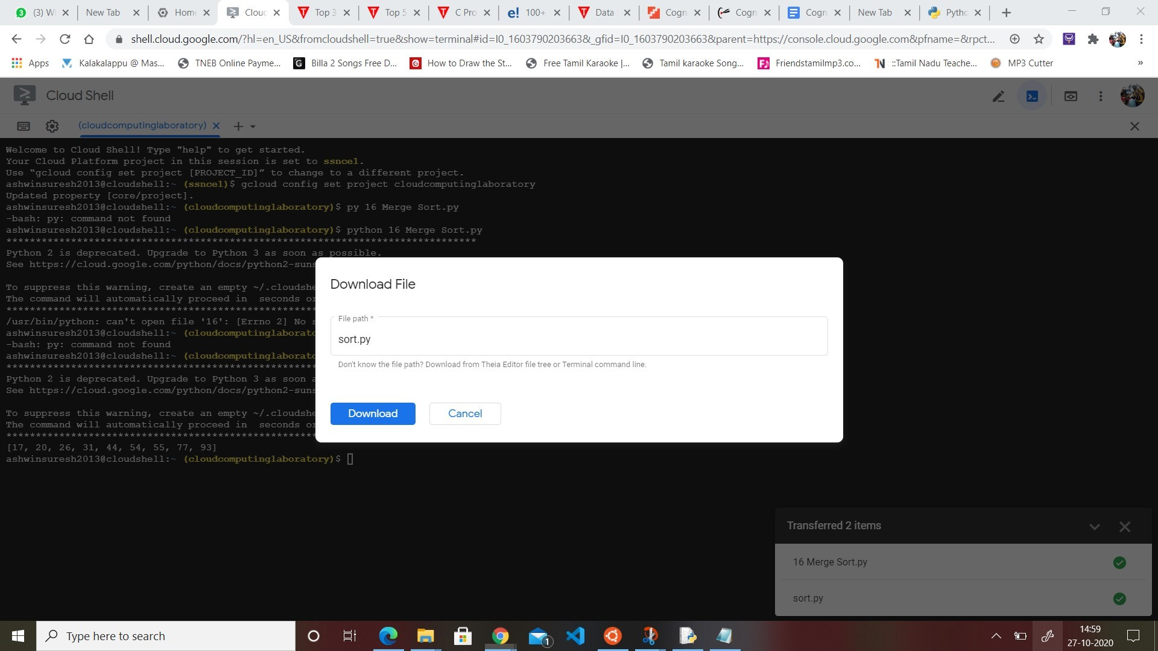

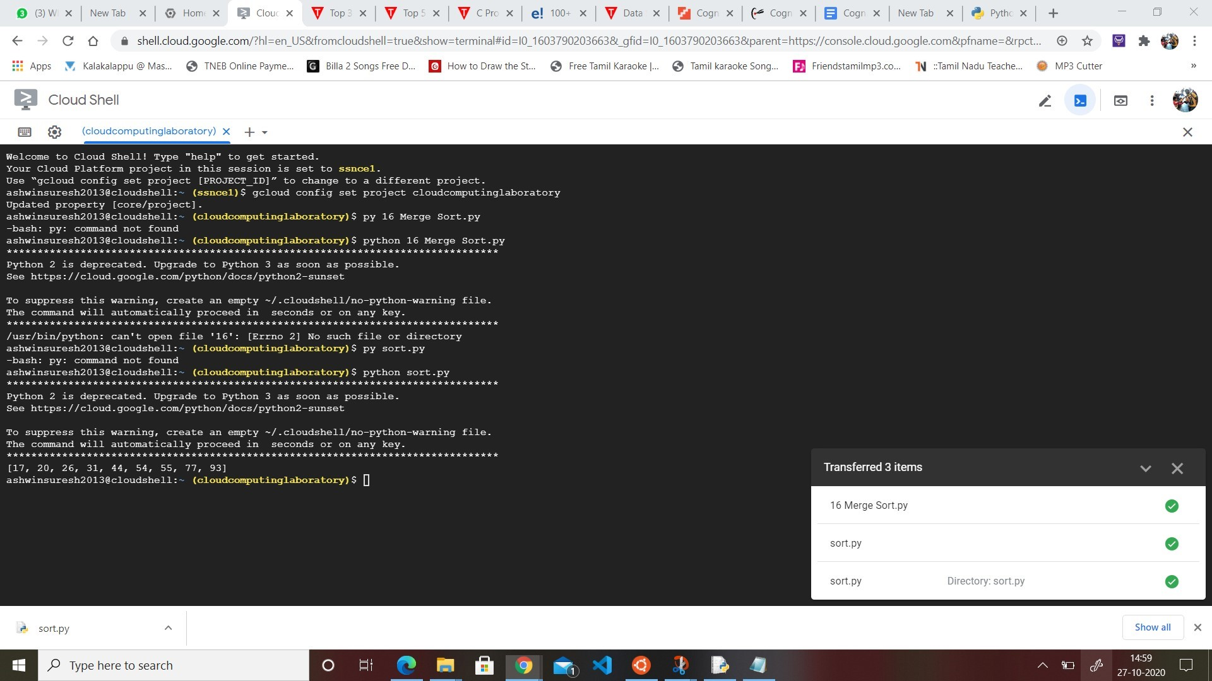

**Result:**

Hence, A Basic Hello World Application Has Been Created And Deployed Successfully Using Python And Google App Engine.